Code:

#define segA 2

#define segB 3

#define segC 4

#define segD 5

#define segE 6

#define segF 7

#define segG 8

#define button 10

int COUNT=0;

int ButtonState;

void setup() {

for (int i=2;i<9;i++)

{

pinMode(i,OUTPUT);

}

pinMode (10, INPUT);

}

void loop() {

ButtonState=digitalRead(button);

if(ButtonState==HIGH)

{

switch (COUNT)

{

case 0:

digitalWrite(segA, HIGH);

digitalWrite(segB, HIGH);

digitalWrite(segC, HIGH);

digitalWrite(segD, HIGH);

digitalWrite(segE, HIGH);

digitalWrite(segF, HIGH);

digitalWrite(segG, LOW);

break;

case 1:

digitalWrite(segA, LOW);

digitalWrite(segB, HIGH);

digitalWrite(segC, HIGH);

digitalWrite(segD, LOW);

digitalWrite(segE, LOW);

digitalWrite(segF, LOW);

digitalWrite(segG, LOW);

break;

case 2:

digitalWrite(segA, HIGH);

digitalWrite(segB, HIGH);

digitalWrite(segC, LOW);

digitalWrite(segD,HIGH);

digitalWrite(segE, HIGH);

digitalWrite(segF, LOW);

digitalWrite(segG, HIGH);

break;

case 3:

digitalWrite(segA, HIGH);

digitalWrite(segB, HIGH);

digitalWrite(segC, HIGH);

digitalWrite(segD, HIGH);

digitalWrite(segE, LOW);

digitalWrite(segF, LOW);

digitalWrite(segG, HIGH);

break;

case 4:

digitalWrite(segA, LOW);

digitalWrite(segB, HIGH);

digitalWrite(segC, HIGH);

digitalWrite(segD, LOW);

digitalWrite(segE, LOW);

digitalWrite(segF, HIGH);

digitalWrite(segG, HIGH);

break;

case 5:

digitalWrite(segA, HIGH);

digitalWrite(segB, LOW);

digitalWrite(segC, HIGH);

digitalWrite(segD, HIGH);

digitalWrite(segE, LOW);

digitalWrite(segF, HIGH);

digitalWrite(segG, HIGH);

break;

case 6:

digitalWrite(segA, HIGH);

digitalWrite(segB, LOW);

digitalWrite(segC, HIGH);

digitalWrite(segD, HIGH);

digitalWrite(segE, HIGH);

digitalWrite(segF, HIGH);

digitalWrite(segG, HIGH);

break;

case 7:

digitalWrite(segA, HIGH);

digitalWrite(segB, HIGH);

digitalWrite(segC, HIGH);

digitalWrite(segD, LOW);

digitalWrite(segE, LOW);

digitalWrite(segF, LOW);

digitalWrite(segG, LOW);

break;

case 8:

digitalWrite(segA, HIGH);

digitalWrite(segB, HIGH);

digitalWrite(segC, HIGH);

digitalWrite(segD, HIGH);

digitalWrite(segE, HIGH);

digitalWrite(segF, HIGH);

digitalWrite(segG, HIGH);

break;

case 9:

digitalWrite(segA, HIGH);

digitalWrite(segB, HIGH);

digitalWrite(segC, HIGH);

digitalWrite(segD, HIGH);

digitalWrite(segE, LOW);

digitalWrite(segF, HIGH);

digitalWrite(segG, HIGH);

break;

}

if (COUNT<10) {

COUNT++;

delay(1000); }

if (COUNT==10) {

COUNT=0;

delay(1000); }

}

}

Output:

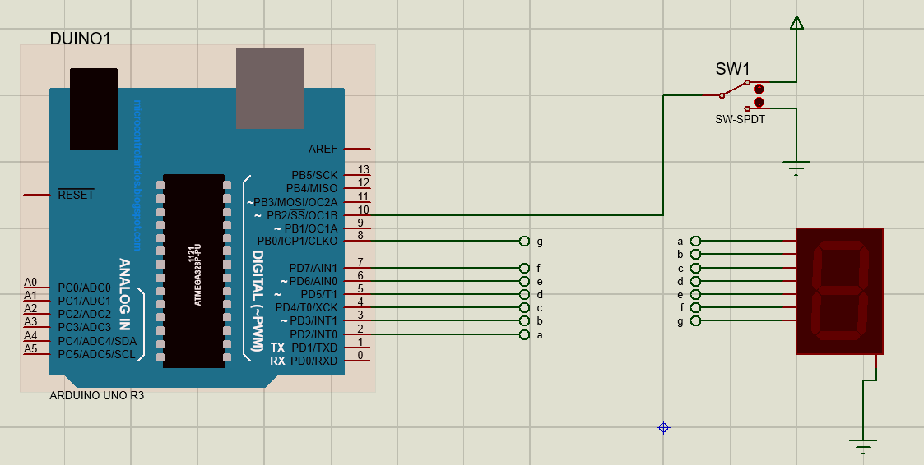

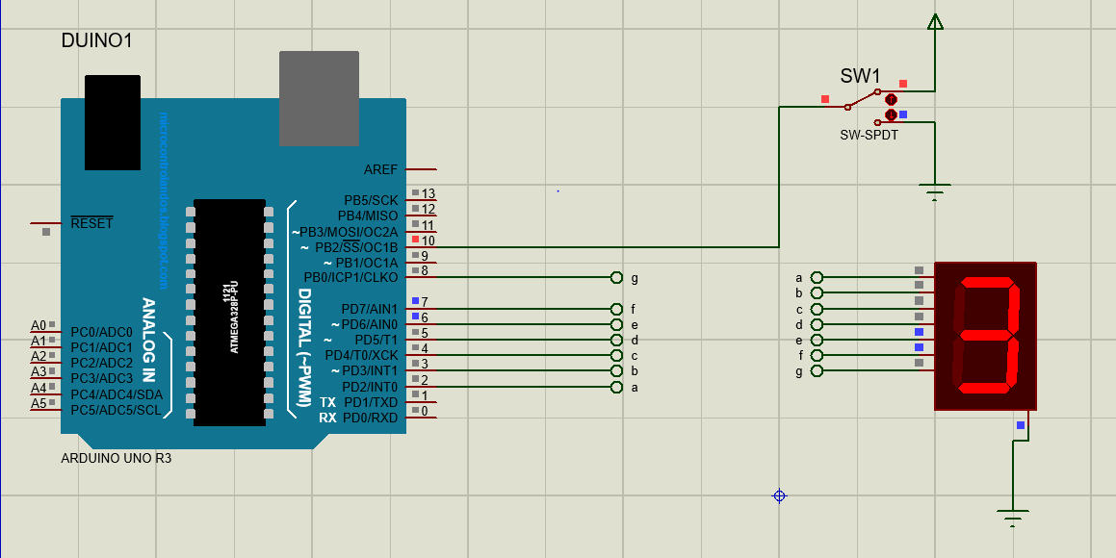

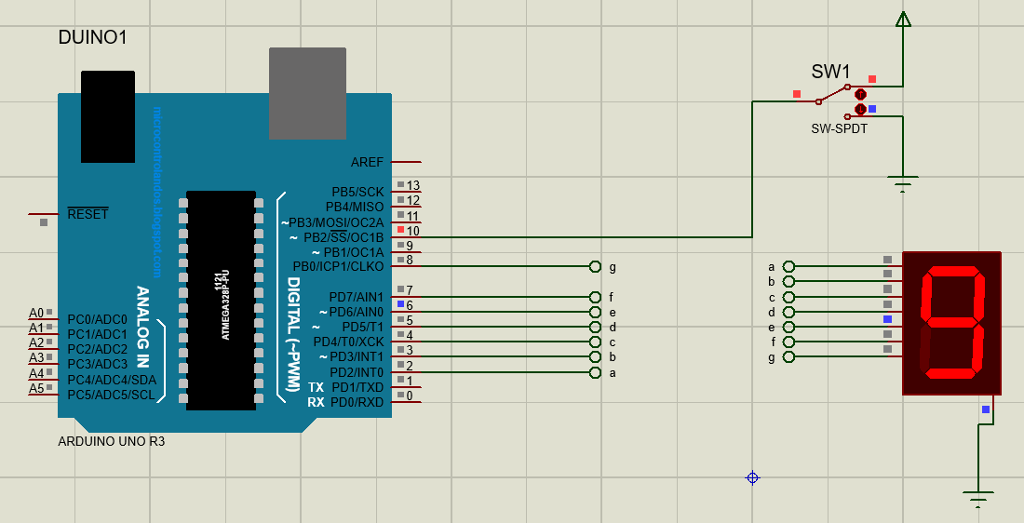

Lab #3

Code:

1:

#include <LiquidCrystal.h>

LiquidCrystal lcd(9, 8, 5, 4, 3, 2);

void setup() {

// put your setup code here, to run once:

lcd.begin(16, 2); // Setting Up the LCD No. of Rows & Columns

}

void loop() {

// put your main code here, to run repeatedly:

lcd.setCursor(0, 0);

lcd.print("Embedded Systems");

lcd.setCursor(0, 1);

lcd.print("BSE-5A");

delay(500);

lcd.clear();

delay(500);

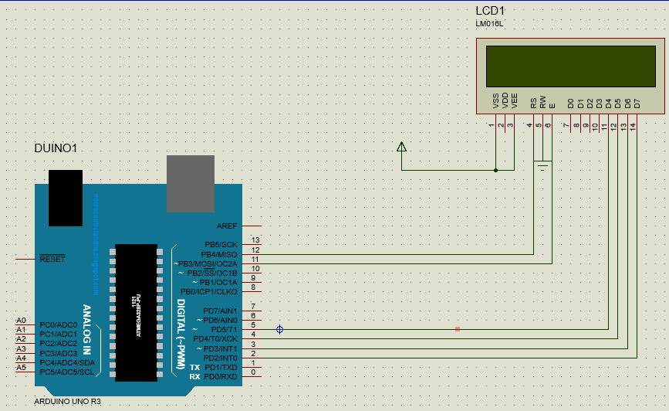

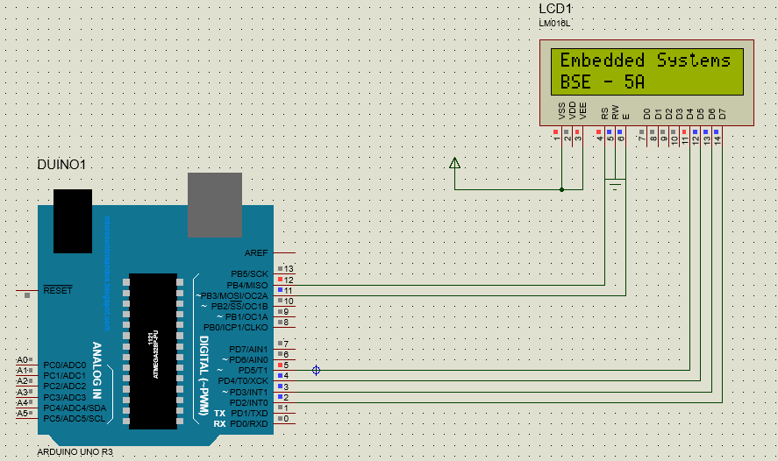

Task 2:

Maryam:

#include <LiquidCrystal.h>

LiquidCrystal lcd(12, 11, 5, 4, 3, 2);

void setup()

{

lcd.begin(16, 2); // Setting Up the LCD No. of Rows & Columns

}

void loop()

{

lcd.setCursor(0, 0);

lcd.print("Maryam Irfan");

lcd.setCursor(0, 1);

lcd.print("69980");

delay(500);

lcd.scrollDisplayLeft();

delay(500);

lcd.scrollDisplayLeft();

delay(500);

lcd.clear();

delay(500);

)

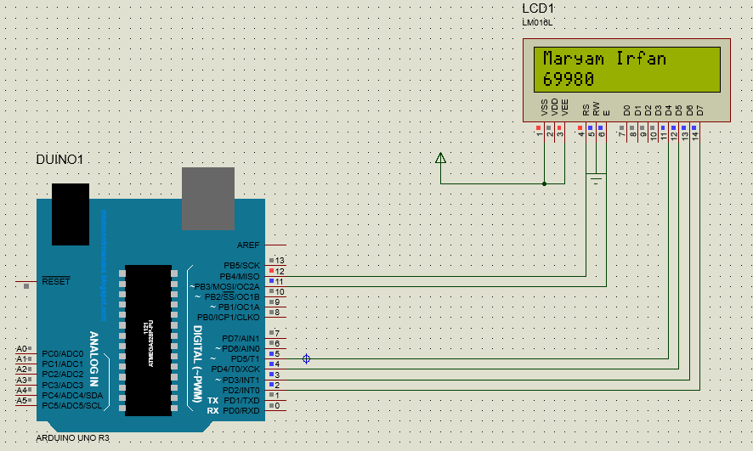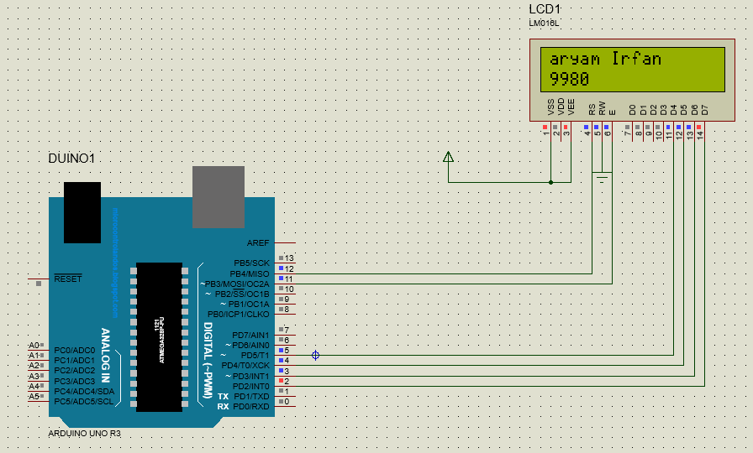

Aqib:

#include <LiquidCrystal.h>

LiquidCrystal lcd(12, 11, 5, 4, 3, 2);

void setup()

{

lcd.begin(16, 2); // Setting Up the LCD No. of Rows & Columns

}

void loop()

{

lcd.setCursor(0, 0);

lcd.print("Aqib Javed");

lcd.setCursor(0, 1);

lcd.print("69968");

delay(500);

lcd.scrollDisplayLeft();

delay(500);

lcd.scrollDisplayLeft();

delay(500);

lcd.clear();

delay(500);

)